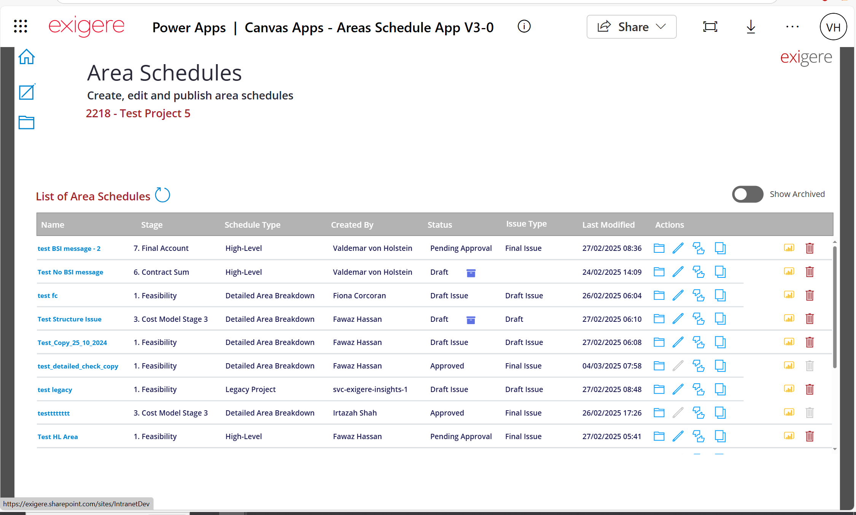
Click Here
Then
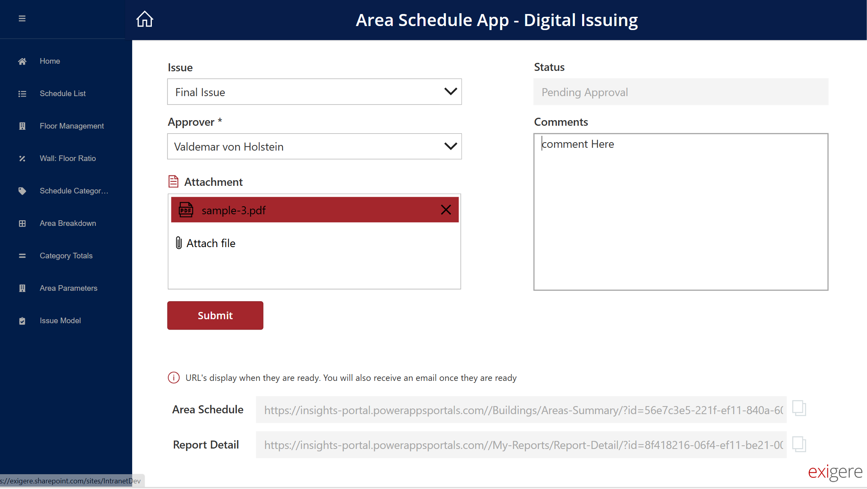
Select draft issue
Select the approver
Upload the attachments you want to share
When done, click submit

